WEBSITE SPECIFICATIONS, INFORMATIONS DESIGN & TAXONOMY AND TECHNICAL BRIEF.

a. Website Objective & Goals
The objective of this website is to provide an online platform for selling football accessories such as football shirts, boots. The website also includes features such as a shopping cart, checkout system, and FAQ section to improve user experience. The website aims to provide a seamless and engaging online shopping experience for users.
According to research by the Nielsen Norman Group, users prefer websites that are easy to navigate and allow them to find products quickly. Therefore, this website is designed with a clear structure, intuitive navigation, and a simplified purchasing process.
The goals of the website in relation to the business are to:
- Allow customers to browse and purchase football products easily.
- Increase product visibility beyond physical location to get more market share.
- Provide a smooth shopping experience through cart and checkout functionality.
- Increase online sales and customer engagement.
- Offer support to users through the FAQ section.

b. Target Audience

The design decisions are influenced by research on user behaviour, ensuring the platform is accessible and easy to use for both experienced and new online shoppers. The target audience for this website includes a wide range of users, as football is a sport enjoyed by people of all ages. However, the primary audience is more specifically defined to ensure effective design and usability.
• Primary audience:
Individuals aged 15–35 years who are active football players, fans, and sports enthusiasts. These users are more likely to purchase football shirts, boots, and accessories online.
• Secondary audience:
Older adults and younger users who have an interest in football, including parents buying for children or casual fans.
• Gender: Both male and female user
• Interests: Football, sports, online shopping and fashion enthusiasts
In terms of technical aptitude, users are expected to:
- Know how to browse websites and navigate menus
- Be able to add items to a cart and proceed to checkout
- Have basic knowledge of using mobile phones or computers

c. Type of Website
The website is an e-commerce website that allows users to browse products, add items to a shopping cart, and complete a checkout process. It also provides additional support content such as FAQs.

2. Information Design & Taxonomy

Information Architecture
The website content is organized into structured categories to support an e-commerce experience. The main sections include Home, Shop, Cart, Checkout, About Us, Contact, FAQ, and Feedback. The Shop section is further divided into Football Shirts and Football Boots.
This structure ensures users can easily browse products, manage their cart, and complete purchases efficiently.
The content of the website is product-focused, supported by images, descriptions, and pricing information to assist users in making informed purchasing decisions.

3. TECHNICAL BRIEF
For the development of my website, I will use a combination of tools to help me design, build, and publish the project effectively.
- Visual Studio Code (VS Code):
I will use VS Code to write and manage my HTML, CSS, and JavaScript code. It makes coding easier by organizing my work and helping me spot errors quickly.
- Canva:
Canva will be used to design wireframes, which will help me plan the layout and overall look of the website before I start coding. I will also use it to create images such as the website logo.
- GitHub:
GitHub will help me store my project files and keep track of any changes I make. This is useful for backing up my work and managing different versions of the website.
- GitHub Pages:
I will use GitHub Pages to publish my website online so that it can be accessed by users.
- Web Browsers (e.g., Google Chrome):
I will use web browsers to test my website during development to make sure it works properly and displays correctly on different device

4. PAGE TEMPLATE DESIGN
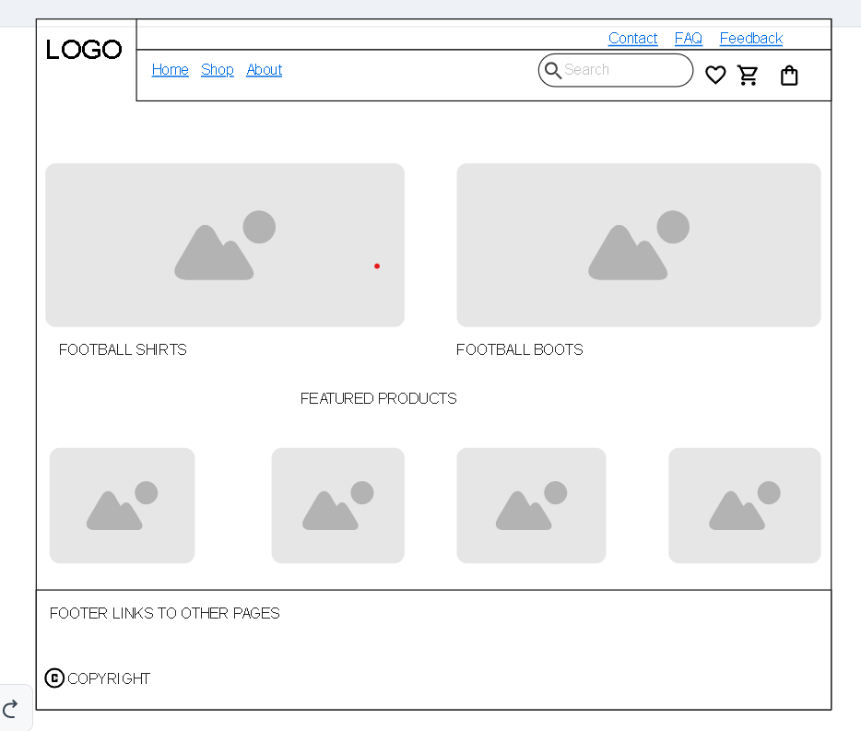

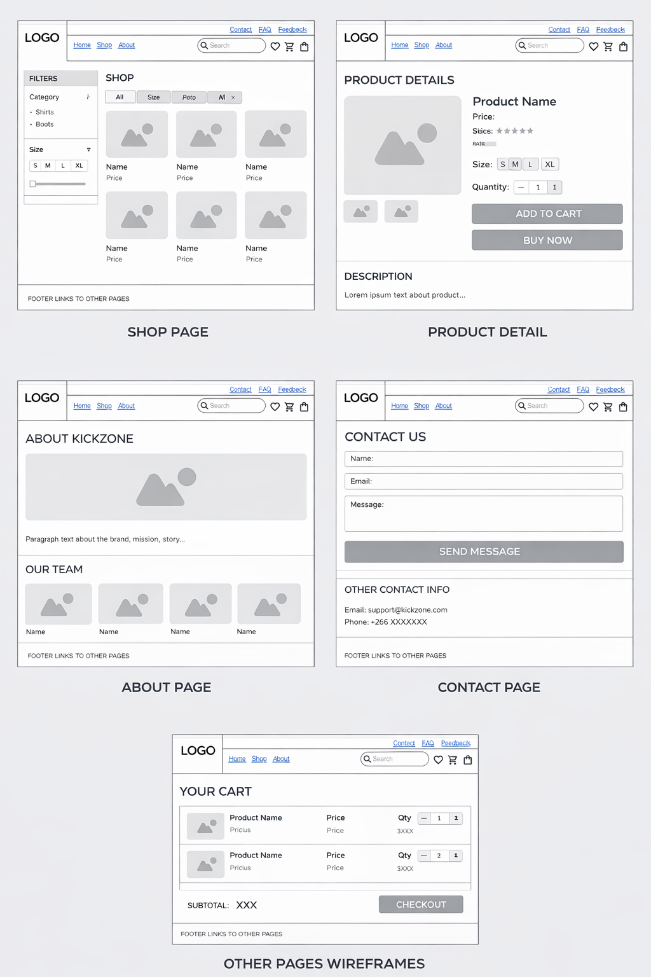

SITE MAP
